February Birthdays
06 Monica Clark
08 Julie Elander
12 Ann Wiggins
20 Aven Yarbrough
28 Angel Claudio
Done by the Tongue
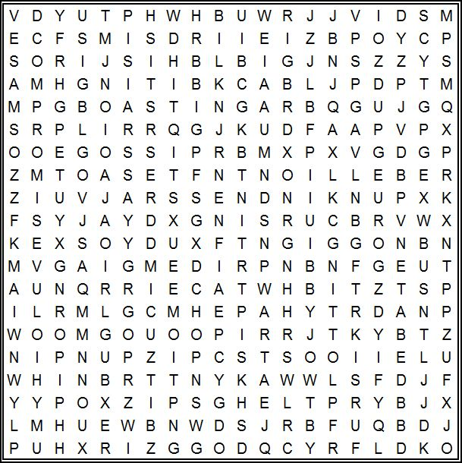
Words to Find: | rebellion | blasphemy | unkindness
lying | compromise | boasting | arguing
deceit | pride | debate | cursing
plotting | mockery | backbiting
murmuring | hypocrisy | gossip

February 12, 2023
UNION VALLEY CHURCH OF CHRIST
9424 FM 35
Royse City, TX 75189
Minister: Bruce Morgan
214-417-1405

Welcome to all of our visitors, members, friends, family.
It is our sincere prayer that something said or done
today will be an inspiration and a blessing to you.
If you are searching for a church home, we encourage you
to seek God in prayer and ask if this is where you should
become a part. After service today, we pray that you will
hang around and allow us to get to know you. We thank
. God for you and hope that you will come back and worship
with us again. “This is the confidence we have in
approaching God: that if we ask anything according
to his will, he hears us”
I John 5:14
OUR RECORDS FOR LAST WEEK:
Sunday Morning Class: 30
Morning Worship: 40
Contribution: $2,988
Remember those on our list that have ongoing health issues:
Bruce Morgan, Monica Clark, Jimmy Jackson, Kristine Hungate & Charles Ray. We also need to pray daily for Vicki Jones & Rick Dunn as they are battling with their cancer treatments.

Please keep Bruce and Monica in your prayers. Bruce has finished his treatments but may start more chemo pills; he is waiting to see what the doctor prescribes. Please keep them in your prayers.
Please pray for continued healing for Danny.

Jimmy Jackson has Chronic Lymphocytic Leukemia. Please remember them in your prayers.
Thank you all for the many prayers for Vicki Jones, she is doing so much better.
Please remember Sam and Macy Elander they need so many prayers to get through this bad time in their life. Please keep this family in your prayers.
Sheila Doan asked for prayers for her cousin Rita Stanley, her cancer has spread and she is going through radiation and Chemo.
Sheila Doan’s cousin Sandra Busby is having skin grafts from the burns she sustained when the house burned. Please lift them all in your prayers.
Please remember to pray for Tom Sharp, the blood thinner he takes has reduced the size of the blood clot enough to get a bit of blood flow around the marble size clot. Tom is still in a lot of pain but can’t have surgery until the clot is gone. Joanna does not have pneumonia just bronchitis, but still not feeling good.
Don Kirby requested prayers for his friend Al Brown, he has stage 5+ cancer throughout his body He is a member of the Quinlan Church of Christ.
Donna Marshall is not doing very well, lot of pain daily, please pray for her.
Please pray for Tom and Mary Coker!
Lei Anne’s dad had several blockages in his heart, they cleared one but he still has another one in 2 weeks. Please keep him in your prayers.
Julie Elander asked for prayers for her friend Sarah and her husband Nick. She has Spina Bifida and has had two very serious surgeries at the same time and she is in a lot of pain.

Please remember to pray for the sick, the ones that are unable to be here and all the members that might be traveling.

Today is our second Sunday Potluck will be February 12th.
We hope everyone will be able to be here for the good food and wonderful fellowship!

Pantry Items

Bath and shower soaps, toothpaste, tooth brushes.

***********************************************

As the plants are inside the building, we need volunteers to water the plants during the week and on Sunday. Please see Monica Clark.

