Rejoice always, pray continually, give thanks in all circumstances: for this is God’s will for you in Christ Jesus.
I Thessalonians 5:16-18

Some people find it difficult to pray, even when they have an immediate need and suspect that the help they desire can only come from God.
Then there’s the Santa Claus problem: you don’t want to make the list too long, or you might not get what you really want. Others just feel unworthy. All these worries are perfectly human, but they all do injustice to God.
God wants us to ask for His help and believe He will give it in love. He’s not too busy, and the number of prayers He will consider have no limit. When He answers, He does so in perfect love, even when the answer is “not now”.
There are no rules about praying. We can pray in church or on the interstate. No fancy words are necessary because God knows what we need before we even ask. God just wants to hear from us.

March 12, 2023
UNION VALLEY CHURCH OF CHRIST
9424 FM 35
Royse City, TX 75189
Minister: Bruce Morgan
214-417-1405
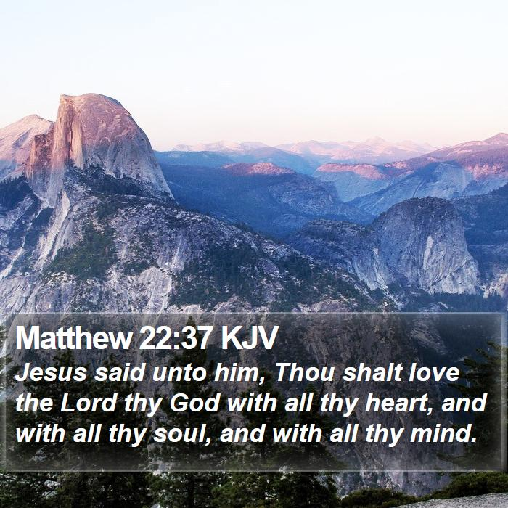
Welcome to all of our visitors, members, friends, family.
.
It is our sincere prayer that something said or done
today will be an inspiration and a blessing to you.
If you are searching for a church home, we encourage you
to seek God in prayer and ask if this is where you should
become a part. After service today, we pray that you will
hang around and allow us to get to know you. We thank
. God for you and hope that you will come back and worship
with us again. “This is the confidence we have in
approaching God: that if we ask anything according
to his will, he hears us”
I John 5:14
OUR RECORDS FOR LAST WEEK:
Sunday Morning Class: 29
Morning Worship: 54
Contribution: $3,073
Remember those on our list that have ongoing health issues:
Bruce Morgan, Monica Clark, Jimmy Jackson, Kristine Hungate & Charles Ray. We also need to pray daily for Vicki Jones & Rick Dunn as they are battling with their cancer treatments.

Please keep Bruce and Monica in your prayers. Bruce has finished his treatments but may start more chemo pills; he is waiting to see what the doctor prescribes. Please keep them in your prayers.
Please pray for continued healing for Danny.

Jimmy Jackson has Chronic Lymphocytic Leukemia. Please remember them in your prayers.
Sheila Doan asked for prayers for her cousin Rita Stanley, her cancer has spread and she is going through radiation and Chemo.
Please remember to pray for Tom Sharp. Tom is still in a lot of pain but can’t have surgery until the clot in his arm is gone.
Don Kirby requested prayers for a close friend of his Bodie Ortega, he has cancer and is going through treatments.
Donna Marshall is not doing very well, she is having a lot of pain and it is hard for her to walk. Please keep up the prayers for her.
Julie Elander asked for prayers for her friend Sarah and her husband Nick. She has Spina Bifida and has had two very serious surgeries at the same time and she is in a lot of pain.
Bruce will have surgery on his arm on April 6th to remove a knot that has grown very large. Surgery will be at Baylor Scott & White. Please pray for Bruce and Monica.
Please pray for Vicki Jones, she was having trouble breathing and went to the hospital, they did a CT scan, she has a pocket of fluid in one of her lungs. They gave her antibiotic’s to keep her from developing pneumonia. She is home now. Please remember Vicki in your prayers.

Please pray for Tom and Mary Coker!

Please remember to pray for the sick, the ones that are unable to be here and all the members that might be traveling.

Our next Second Sunday Potluck will be March 19th instead of the 12th.
We hope everyone will be able to be here for the good food and wonderful fellowship!

Pantry Items

Bath and shower soaps, toothpaste, tooth brushes.

***********************************************

As the plants are inside the building, we need volunteers to water the plants during the week and on Sunday. Please see Monica Clark.
March Birthdays Greeters
07 David Aston March Pam Kirby
08 Jimmy Jackson April Patricia Aston
18 Paula Blake May Sally Claudio
25 Tom Coker

