Tid Bits

“For what it’s worth: It’s never too late to be whoever you want to be. I hope you live a life that you are proud of, and if you find that you’re not, I hope you have the strength to start over.”

Too often we underestimate the power of a touch, a smile, a kind word, a listening ear, an honest compliment, or the smallest act of caring, all of which have the potential to turn a life around.

The deepest level of worship is praising God in spite of the pain, thanking God during the trials, trusting Him when we’re tempted to lose Hope and LOVING HIM when He seems so distant and far away. At my lowest, God is my hope. At my darkest, God is my light. At my weakest, God is my strength. At my saddest, God is my comforter.

I believe churches are meant for praising God. But so are 2am car rides, showers, coffee shops, the gym, conversations with friends, strangers, etc. Don’t let a building confine your faith because we will never change the world by just going to church, we need to be the church.

April 30, 2023
UNION VALLEY CHURCH OF CHRIST
9424 FM 35
Royse City, TX 75189
Minister: Bruce Morgan
214-417-1405
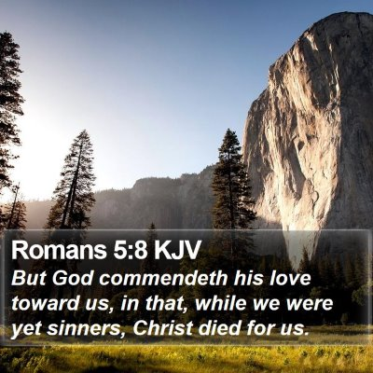
Welcome to all of our visitors, members, friends, family.
.
It is our sincere prayer that something said or done
today will be an inspiration and a blessing to you.
If you are searching for a church home, we encourage you
to seek God in prayer and ask if this is where you should
become a part. After service today, we pray that you will
hang around and allow us to get to know you. We thank
. God for you and hope that you will come back and worship
with us again. “This is the confidence we have in
approaching God: that if we ask anything according
to his will, he hears us”
I John 5:14

OUR RECORDS FOR LAST WEEK:
Sunday Morning Class: 31
Morning Worship: 45
Contribution: $1,512

Remember those on our list that have ongoing health issues:
Bruce Morgan, Monica Clark, Jimmy Jackson, Kristine Hungate & Charles Ray. We also need to pray daily for Vicki Jones & Rick Dunn as they are battling with their cancer treatments.
/
Please keep Bruce and Monica in your prayers. Bruce has finished his treatments but may start more chemo pills; he is waiting to see what the doctor prescribes. Please keep them in your prayers.
Danny had surgery to remove some of the hardware and screws from his ribs. Please keep Danny and Sherry in your prayers.

Jimmy Jackson has Chronic Lymphocytic Leukemia. Please remember him in your prayers.
Sheila Doan asked for prayers for her cousin Rita Stanley, her cancer has spread and she is going through radiation and Chemo.
Tom Sharp was having a CT scan but they missed his vein when trying to put the contrast in, it flooded his arm and has left him with debilitating pain, which will last him for quite a while. Please keep praying for Tom and Joanna. Also their elderly aunt has cancer in 2 locations and the chemo is making her very sick, please pray for her too.
Don Kirby requested prayers for a close friend of his Bodie Ortega; he has cancer and is going through treatments.
Donna Marshall is not doing very well. Please keep up the prayers for her.
Please pray for Vicki Jones, she had 7 biopsy’s and two were bad, they will need to be removed.
Please pray for Ann and John Wiggins, Ann is still having problems with her heart and has no energy. She has a nurse and a therapist coming at different times each week. Please continue praying for them.
Monty and Sheila’s granddaughter, McKinley had an accident on a 4 wheeler, she will be having an MRI to make sure nothing is wrong.
Roger Price, a former member here, had major surgery on his abdomen and upper torso. He’s home but please pray for him.
Bruce has a friend that needs our prayers, he has diabetes and is on dialysis. They are wanting to remove one of his legs. He has been Bruce’s friend for about 42 years. Please pray for him.
Please pray for Tom and Mary Coker!

Our Second Sunday Potluck will be May 14th. This is also Mother’s Day! We hope everyone will be able to make this date and enjoy the good food and wonderful fellowship.
***********************************************

We need volunteers to water the plants during the week and on Sunday. Please see Monica Clark.
May Birthdays
01 Lester Humphreys
05 Donna Marshall
28 Danny Myre

Greeters
May Sally Claudio

