Living Temple

Once the Israelites built the temple, it was the center of their life. They not only worshiped and sacrificed there; they celebrated all their feast days there. On this very first visit, two Spirit filled people, Simeon and Anna, recognized Him as the One sent for our salvation. When Jesus was only twelve years old he was found in the temple again. He astonished the teachers with his understanding. Questioned by his parents, He answered, Didn’t you know I had to be in my Father’s house? So, in our reading today, it is not unusual to find Him back teaching in the temple. Here He is confronted by the priest and scribes, questioning His authority. His life is threatened, but His time has not come. He continues His work in His Father’s house.

Paul tells us that we are a temple, where the Holy Spirit lives. Seeing how Jesus spent His time in the temple, let us be aware of his presents in our lives, see His work, praise His power and love. Worship the Lord in the splendor of His holiness.

The voice of the Lord is powerful; the voice of the Lord is majestic. Psalm 29:2, 4

May 07, 2023
UNION VALLEY CHURCH OF CHRIST
9424 FM 35
Royse City, TX 75189
Minister: Bruce Morgan
214-417-1405
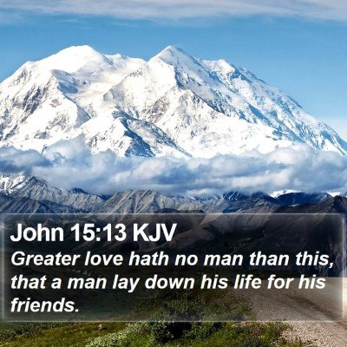
Welcome to all of our visitors, members, friends, family.
.
It is our sincere prayer that something said or done
today will be an inspiration and a blessing to you.
If you are searching for a church home, we encourage you
to seek God in prayer and ask if this is where you should
become a part. After service today, we pray that you will
hang around and allow us to get to know you. We thank
. God for you and hope that you will come back and worship
with us again. “This is the confidence we have in
approaching God: that if we ask anything according
to his will, he hears us”
I John 5:14
OUR RECORDS FOR LAST WEEK:
Sunday Morning Class: 23
Morning Worship: 37
Contribution: $3,177
Remember those on our list that have ongoing health issues:
Bruce Morgan, Monica Clark, Jimmy Jackson, Kristine Hungate & Charles Ray. We also need to pray daily for Vicki Jones & Rick Dunn as they are battling with their cancer treatments.
/
Please keep Bruce and Monica in your prayers. Bruce has finished his treatments but may start more chemo pills; he is waiting to see what the doctor prescribes. Please keep them in your prayers.
Danny had surgery to remove some of the hardware and screws from his ribs. Please keep Danny and Sherry in your prayers.

Jimmy Jackson has Chronic Lymphocytic Leukemia. Please remember him in your prayers.
Sheila Doan asked for prayers for her cousin Rita Stanley, please keep Rita in your prayers.
Please keep Tom and Joanna Sharp in your prayers.
Don Kirby requested prayers for a close friend of his Bodie Ortega; he has cancer and is going through treatments.
Donna Marshall is not doing very well. Please keep up the prayers for her.
Please keep Vicki Jones in your prayers.
Please pray for Ann and John Wiggins, Ann is still having problems with her heart and has no energy. She has a nurse and a therapist coming at different times each week. Please continue praying for them..
Roger Price, a former member here, had major surgery on his abdomen and upper torso. He’s home but please pray for him.
Bruce has a friend that needs our prayers, he has diabetes and is on dialysis. They are wanting to remove one of his legs. He has been Bruce’s friend for about 42 years. Please pray for him.
David Doederline are friends of the Elander’s, his cancer was in remission for 13 years but he now has a brain tumor, Please pray for David and his family.
They also have a 14 year old friend Eli Wyatt, member of the church in Juneau, he is good friend of Julie and Kelly’s daughter Liz. He has a rare form of cancer and will be at the Ronald McDonald house in Seattle for some time. Needs lots of prayers.
Please pray for Tom and Mary Coker!

Our Second Sunday Potluck will be May 14th. This is also Mother’s Day! We hope everyone will be able to make this date and enjoy the good food and wonderful fellowship.
***********************************************

We need volunteers to water the plants during the week and on Sunday. Please see Monica Clark.
May Birthdays
01 Lester Humphreys
05 Donna Marshall
28 Danny Myre

Greeters
May Sally Claudio

