God Has Given Us A Song
It’s interesting to note that birds sing because they have a syrinx instead of a larynx. The syrinx is the bird’s voice box, an organ that lies deep in a bird’s chest and is uniquely fashioned for song. That is the natural explanation for their gift.
Another reason why birds sing is simply because their Creator put a song in their hearts (Psalm 104:12). Each bird is created to draw our hearts up to our Creator — they are reminders that He has given us a song as well so we may sing His praise (Hebrews 13:15; cf. Hosea 14:2).
So when we hear God’s little birds singing their hearts out, let’s remember to sing our own song of salvation (cf. Isaiah 12:2). Lift up our voice — no matter if it is harmonious, hoarse, or harsh — and then join with them in praising our Creator, Redeemer, and Lord.
David joyously observes that the birds of the air “sing among the branches” (Psalm 104:12).
Thus:
“I will sing to the Lord as long as I live; I will sing praise to my God while I have my being” (Psalm 104:33).
(By Mike Riley)
He took my burdens all away, up to a brighter day,
He gave me a song, a wonderful song,
A wonderful song I now can sing, in my heart joy bells ring,
He gave me a song, a wonderful song.
He gave me a song, to sing about,
He lifted me from sin and doubt;
Oh praise His name, He is my King,
a wonderful song, He is to me —A.H. Howard

June 17, 2023
UNION VALLEY CHURCH OF CHRIST
9424 FM 35
Royse City, TX 75189
Minister: Bruce Morgan
214-417-1405
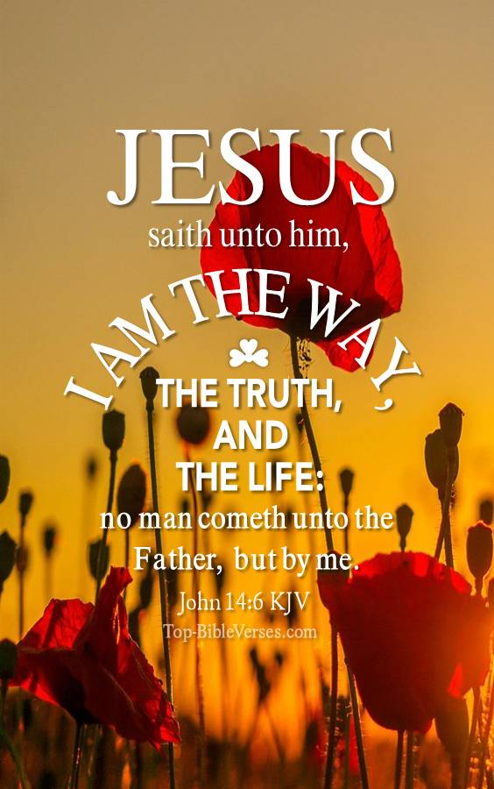
Welcome to all of our visitors, members, friends, family.
.
It is our sincere prayer that something said or done
today will be an inspiration and a blessing to you.
If you are searching for a church home, we encourage you
to seek God in prayer and ask if this is where you should
become a part. After service today, we pray that you will
hang around and allow us to get to know you. We thank
. God for you and hope that you will come back and worship
with us again. “This is the confidence we have in
approaching God: that if we ask anything according
to his will, he hears us”
I John 5:14
OUR RECORDS FOR LAST WEEK:

Sunday Morning Class: 21
Morning Worship: 38
Contribution: $1,554

Remember those on our list that have ongoing health issues:
Bruce Morgan, Monica Clark, Jimmy Jackson, Kristine Hungate & Charles Ray. We also need to pray daily for Vicki Jones & Rick Dunn as they are battling with their cancer treatments.

Please keep Bruce and Monica in your prayers.
Please keep Danny and Sherry in your prayers.

Jimmy Jackson has Chronic Lymphocytic Leukemia. Please remember him in your prayers.
Sheila Doan asked for prayers for her cousin Rita Stanley, please keep Rita in your prayers.
Please keep Tom and Joanna Sharp in your prayers.
Don Kirby requested prayers for a close friend of his Bodie Ortega; he has cancer and is going through treatments.
Donna Marshall is doing better and she is now home. Please keep up the prayers for her.
Please keep Vicki Jones in your prayers.
Please pray for Ann and John Wiggins, Ann is still having problems with her heart and has no energy. She has a nurse and a therapist coming at different times each week. Please continue praying for them.
Bruce’s friend Frank Bell passed from this life on June 7th. As of yet no arrangements have been made. Please pray for his family and for Bruce as he lost his friend of over 42 years.
David Doederline friends of the Elander’s, his cancer was in remission for 13 years but he now has a brain tumor. Please pray for David and his family.
They also have a 14 year old friend Eli Wyatt, member of the church in Juneau, he is good friend of Julie and Kelly’s daughter Liz. He has a rare form of cancer and will be at the Ronald McDonald house in Seattle for some time. Needs lots of prayers.
Please keep Roger Price in your prayers as he continues to heal.
Please keep Monty and Sheila in your prayers, Monty will have shoulder surgery soon.
Luis Claudio’s cousin Carlos Gracia went to the hospital, they thought he had an aneurism but it turned out to be a brain bleed. He is still in the hospital but doing better.

This is our Second Sunday Potluck that we put off till Father’s Day June 18th . We hope everyone will be able to make this date and enjoy the good food and wonderful fellowship.
***********************************************

We need volunteers to water the plants during the week and on Sunday. Please see Monica Clark.
June Birthdays
04 Mike Carrell
08 Pam Kirby
13 Alyssa Chandler
17 Kathy Carrell
23 Alex Claudio

Greeters
June
July

