God’s Workmanship

For we are God’s handiwork, created by Christ Jesus to do good works, which God prepared in advance for us to do.

Ephesians 2:10 NIV

Did you know that the word workmanship indicates an ongoing process? So, if we are God’s workmanship, we are God’s ongoing project. In other words, He isn’t finished with us yet! Isn’t that good news? I am so glad! I’d hate to think that I was as good as I am going to get.

So, if you are feeling less than adequate today, cheer up! God is not through with you yet! He is working on you right now, even as you are reading this. He knew that we would all make big mistakes, but this scripture says that He created us in Christ Jesus to do good works. He’s prepared the road for us. He’s been planning our steps long before we arrived here, so don’t worry!

We may not be where we want to be today, but we’re on the right road. After all, we’re God’s workmanship, and He only turns out good stuff!

Attention All Men

There will be a Mens Meeting right after church services, please plan to attend.

July 2!, 2023
UNION VALLEY CHURCH OF CHRIST
9424 FM 35
Royse City, TX 75189
Minister: Bruce Morgan
214-417-1405
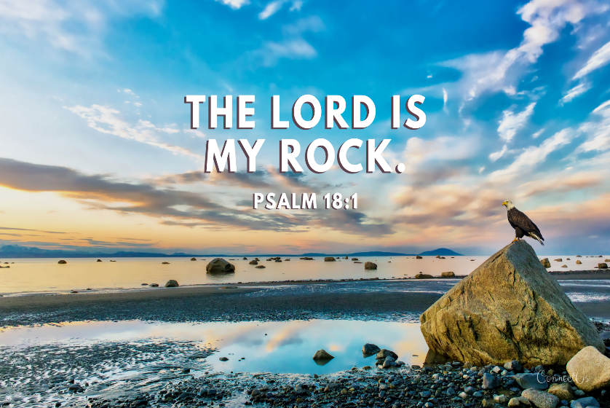
Welcome to all of our visitors, members, friends, family.
.
It is our sincere prayer that something said or done
today will be an inspiration and a blessing to you.
If you are searching for a church home, we encourage you
to seek God in prayer and ask if this is where you should
become a part. After service today, we pray that you will
hang around and allow us to get to know you. We thank
. God for you and hope that you will come back and worship
with us again. “This is the confidence we have in
approaching God: that if we ask anything according
to his will, he hears us”
I John 5:14
OUR RECORDS FOR LAST WEEK:

Sunday Morning Class: 25
Morning Worship: 53
Contribution: $2,893
Remember those on our list that have ongoing health issues:
Bruce Morgan, Monica Clark, Jimmy Jackson, Kristine Hungate & Charles Ray. We also need to pray daily for Vicki Jones & Rick Dunn as they are battling with their cancer treatments.

Please keep Bruce and Monica in your prayers.
Please keep Danny and Sherry in your prayers.

Keep Jimmy Jackson in your prayers.
Sheila Doan asked for prayers for her cousin Rita Stanley, please keep Rita in your prayers.
Please keep Tom and Joanna Sharp in your prayers.
Don Kirby requested prayers for a close friend of his Bodie Ortega; he has cancer and is taking treatments.
Donna Marshall’s surgery is set for July 17. Please remember to pray for her and the doctors attending her.
Please keep Vicki Jones in your prayers. Along with her
Leukemia, she is a kidney stone maker, they are talking about going into her kidneys and cleaning the stones out. No time set yet.
Please keep praying for Ann and John Wiggins.
Please keep Monty and Sheila in your prayers, Monty will have shoulder surgery on the 27th.
Cheryl Hargrove had ankle replacement and will be in rehab for about 20 days. Please pray for her.
Please pray for Bertis Hall, she is a friend of the Myre’s and Blake’s, from Lakeside church. She has kidney cancer that has spread throughout her body and has chosen to go home until she goes to meet the Lord.
Please keep Lei Ann and Alyssa in your prayers. Lei Ann has been having seizures again and Alyssa is having migraines.

Sheila Talley asked for prayers for her Father, James Bowen. He was taken to the hospital in Greenville with what they believe to be his heart and a hiatal Hernia. He is home but will have more tests done.

Our next Second Sunday Potluck will be August 13th. We hope everyone will be able to stay and enjoy the good food and wonderful fellowship.
***********************************************

We need volunteers to water the plants during the week and on Sunday. Please see Monica Clark.
July Birthdays
02 Yaretzi Stone
05 Joanna Sharp
10 Monty Doan
13 Pauline Pribble
13 Dub Shepperd
21 Juanita (Janie) Reyes
23 Bruce Morgan
27 Luis Claudio

Greeters

July

