Bad Guys and Rascals of the Bible
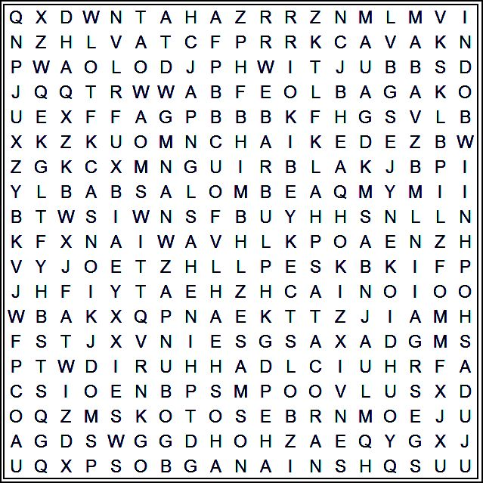
Words to Find:
Hophni | Phinehas | Cain | Samson
Rehoboam | Judas | Ahab | Nabal
Hazael | Satan | Adonijah | Horam
Herod | Zedekiah | Goliath | Eglon
Nadab | Absalom | Ahaz

July 30, 2023
UNION VALLEY CHURCH OF CHRIST
9424 FM 35
Royse City, TX 75189
Minister: Bruce Morgan
214-417-1405
 Welcome to all of our visitors, members, friends, family.
.
It is our sincere prayer that something said or done
today will be an inspiration and a blessing to you.
If you are searching for a church home, we encourage you
to seek God in prayer and ask if this is where you should
become a part. After service today, we pray that you will
hang around and allow us to get to know you. We thank
. God for you and hope that you will come back and worship
with us again. “This is the confidence we have in
approaching God: that if we ask anything according
to his will, he hears us”
I John 5:14

OUR RECORDS FOR LAST WEEK:

Sunday Morning Class: 30
Morning Worship: 39
Contribution: $1,665
Remember those on our list that have ongoing health issues:
Bruce Morgan, Monica Clark, Jimmy Jackson, Kristine Hungate & Charles Ray. We also need to pray daily for Vicki Jones & Rick Dunn as they are battling with their cancer treatments.

Please keep Bruce and Monica in your prayers.
Please keep Danny and Sherry in your prayers.

Keep Jimmy Jackson in your prayers.
Sheila Doan asked for prayers for her cousin Rita Stanley, please keep Rita in your prayers.
Please keep Tom and Joanna Sharp in your prayers.
Don Kirby requested prayers for a close friend of his Bodie Ortega; he has cancer and is taking treatments.
Donna Marshall’s surgery is set for July 17. Please remember to pray for her and the doctors attending her.
Please keep Vicki Jones in your prayers. Along with her
Leukemia, she is a kidney stone maker, they are talking about going into her kidneys and cleaning the stones out on August 8th.
Please keep praying for Ann and John Wiggins.
Please pray for Bertis Hall, she is a friend of the Myre’s and Blake’s, from Lakeside church. Thanks to all the prayers, she is much better and is back home. Please continue praying for her.
Please keep Lei Ann and Alyssa in your prayers. Lei Ann has been having seizures again and Alyssa is having migraines.
The Crowder’s are in need of our prayers. Curtis is having hip problems and Carolyn has a lot of skin cancers that she is having removed. Please remember them in your prayers.
Monty had his shoulder surgery on the 27th, surgery went well but they had to go back in because they found a crack in his humerus bone and had to put a plate on it. He is finally home and Sheila said he was doing a lot better! Please keep up the prayers.

Our next Second Sunday Potluck will be August 13th. We hope everyone will be able to stay and enjoy the good food and wonderful fellowship.
***********************************************

We need volunteers to water the plants during the week and on Sunday. Please see Monica Clark.
August Birthdays
07 Karen Shepperd
10 Don Kirby
13 Pauline Pribble
15 Cesia Stone
22 Sally Claudio

Greeters

July

