Calmed by His Love

“The Lord your God is in your midst, a mighty one who will save; He will rejoice over you with gladness; He will quiet you by His love; He will exult over you with loud singing.”

What is causing you unrest today? Inadequacy? Lack of strength? Poor finances?
God wants you to know that He is with you. He sees your circumstances, your concerns, your worries. And He wants you to know that He’s the mighty one who will save you. He is rejoicing over you with gladness, exulting over you with loud singing. Why?
Because He loves you. And He wants to wrap you in His love that’s like a thick comforter on a cold winter evening. He wants us to rest in His love. For only His love can calm the fear that hinders you from what He has tasked you to do.
God’s love sent His Son to die for you, that you might receive everything you need pertaining to life and godliness. His love enables you to keep on going even when you are ready to give up. His love allows you to rest, to gain strength, to be still in the midst of the storm that is raging all around you. The waters will not rise enough to drown you, nor will the raging fire consume you.

October 29, 2023
UNION VALLEY CHURCH OF CHRIST
9424 FM 35
Royse City, TX 75189
Minister: Bruce Morgan
214-417-1405
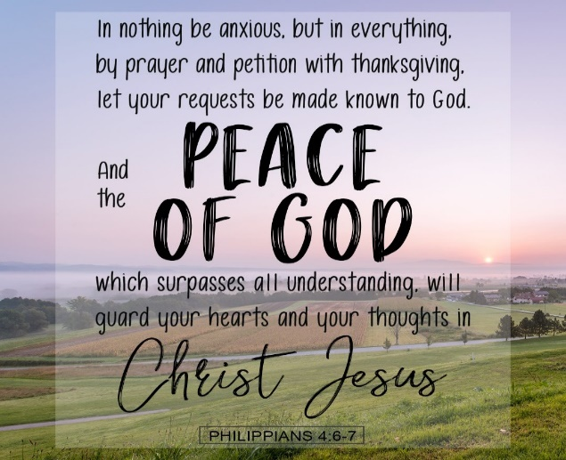
Welcome to all of our visitors, members, friends, family.

It is our sincere prayer that something said or done
today will be an inspiration and a blessing to you.
If you are searching for a church home, we encourage you
to seek God in prayer and ask if this is where you should
become a part. After service today, we pray that you will
hang around and allow us to get to know you. We thank
. God for you and hope that you will come back and worship
with us again. “This is the confidence we have in
approaching God: that if we ask anything according
to his will, he hears us”
I John 5:14

OUR RECORDS FOR LAST WEEK:

Sunday Morning Class: 17
Morning Worship: 43
Wednesday Class 13
Contribution: $2,353
Remember those on our list that have ongoing health issues:
Bruce Morgan, Monica Clark, Jimmy Jackson, Kristine Hungate & Charles Ray. We also need to pray daily for Vicki Jones & Rick Dunn as they are battling with their cancer treatments.

Please keep Bruce and Monica in your prayers. Bruce is still having pain but he is doing better. Please keep him in our prayers.
Please keep Danny and Sherry in your prayers.

Keep Jimmy Jackson in your prayers, his white blood cells have gone up a lot and the doctor is looking into other medications to try.
Please keep Tom and Joanna Sharp in your prayers.
Vicki Jones is having problems with her heart and blood pressure. She spent several days in the hospital with bulging disk at L4 and L5. She had several injections and is home now.
Please keep praying for Ann and John Wiggins.
The Crowder’s are in need of our prayers. Please remember them in your prayers.
Pray for Sheila Doan and their family, her brother-in-law Tom Watson is better but still has cancer and needs a new treatments plan. Please keep him and the family in your prayers.
Kelly Elander’s brother-in-law Rick Dunn now has cancer that has metastasized on his hip and he had radiation on Tuesday. Please remember to pray for Rick and their family.
Donna Marshall has asked for prayers for Gayle Marshall, she is having more cancer concerns and will have more surgery.
Shelia Talley’s dad, James Bowen, is having problems and is in the ER. They think he might need a pacemaker. Please keep up the prayers for him and the family that the ones caring for him will figure out what will be the best treatment for him.

Our Fall Festival was a great success and everyone enjoyed all the games and food! Thanks to Seth and Cesia for all the work they put into making this event a success and thanks to all who manned a booths, the games and did all the clean up. We had 61 that came to enjoy our festival! Thank you all for making this a great event!

Pray for the Joshua project.

Our next second Sunday Potluck will be November 12th. We hope everyone will be able to stay and enjoy the good food and wonderful fellowship.
***********************************************

We need volunteers to water the plants during the week and on Sunday. Please see Monica Clark.
October Birthdays
06 Mark Kirby
12 Patricia Jackson
27 Tzeitel Stone
29 Sherry Myre
29 Kelly Elander
29 Tom Sharp
30 Jerry Stevens

