We were so glad and happy for these two young souls that came forward on Sunday to put the Lord
on in Baptism.

Meet Dylan Lay and Valerie Claudio.

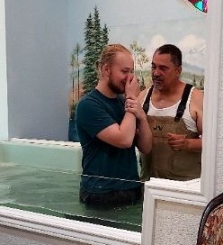


November 12, 2023
UNION VALLEY CHURCH OF CHRIST
9424 FM 35
Royse City, TX 75189
Minister: Bruce Morgan
214-417-1405
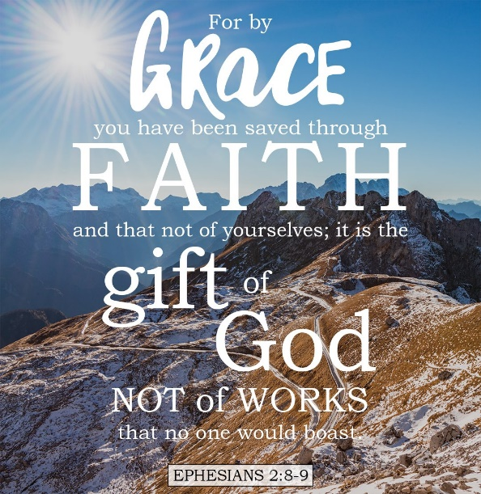
Welcome to all of our visitors, members, friends, family.

It is our sincere prayer that something said or done
today will be an inspiration and a blessing to you.
If you are searching for a church home, we encourage you
to seek God in prayer and ask if this is where you should
become a part. After service today, we pray that you will
hang around and allow us to get to know you. We thank
. God for you and hope that you will come back and worship
with us again. “This is the confidence we have in
approaching God: that if we ask anything according
to his will, he hears us”
I John 5:14

OUR RECORDS FOR LAST WEEK:

Sunday Morning Class: 35
Morning Worship: 61
Wednesday Night Class 11
Contribution: $2,809
Remember those on our list that have ongoing health issues:
Bruce Morgan, Monica Clark, Jimmy Jackson, Kristine Hungate & Charles Ray. We also need to pray daily for Vicki Jones & Rick Dunn as they are battling with their cancer treatments.

Please keep Bruce and Monica in your prayers. Bruce is still having pain but he is doing better. Please keep him in our prayers.
Please keep Danny and Sherry in your prayers.

Keep Jimmy Jackson in your prayers, his white blood cells have gone up a lot and the doctor is looking into other medications to try.
Please keep Tom and Joanna Sharp in your prayers.
Vicki Jones is having problems with her heart and blood pressure. She spent several days in the hospital with bulging disk at L4 and L5. She had several injections and is home now.
Please keep Ann and John Wiggins in your prayers.
The Crowder’s are in need of our prayers. Please remember them in your prayers.
Pray for Sheila Doan’s brother-in-law Tom Watson, he is better but needs a new treatment plan. Please keep him and the family in your prayers.
Kelly Elander’s brother-in-law Rick Dunn now has cancer that has metastasized on his hip and he had radiation on Tuesday. Please remember to pray for Rick and their family.
Donna Marshall has asked for prayers for Gayle Marshall, she is having more cancer concerns and will have more surgery.
Shelia Talley’s dad, James Bowen, is having problems and is in the ER. They think he might need a pacemaker. Please keep up the prayers for him and the family that the ones caring for him will figure out what will be the best treatment for him.

Pray for the Joshua project.

We will not have our Sunday Potluck this month.
Our next second Sunday Potluck will be December 10th. We hope everyone will be able to stay and enjoy the good food and wonderful fellowship.
***********************************************

We need volunteers to water the plants during the week and on Sunday. Please see Monica Clark.
December Birthdays
10 Seth Stone
19 Valerie Claudio
24 Patricia Aston
28 Lei Anne McMillon

***********************************
If you are going to believe in everything
you read….

Then start with your BIBLE!

