Five Things No One Will Regret On Judgment Day
By Mike Riley
As Christians, we all have regrets in our lives — things we should have done but didn’t do, and things we shouldn’t have done, but did them anyway. However, there are five things which no one will regret on the day of judgment. If we abide by these principles, we can have boldness to stand before God’s throne on that day (1 John 4:17-NKJV).
- Putting God and His kingdom first in our lives (Matthew 6:33-NKJV; cf. Deuteronomy 28:45-47-NKJV).
- Respecting and caring for our parents (Ephesians 6:1-2-NKJV; cf. Exodus 20:12-NKJV).
- Marrying a faithful Christian (1 Corinthians 9:5-NASB; cf. Psalm 34:3-NKJV).
- Giving generously to those in need (2 Corinthians 8:1-5-NKJV; 2 Corinthians 9:6-15-NKJV).
- Saving lost souls for the Savior (1 Timothy 4:16-NKJV; cf. Psalm 51:12-13-NKJV).
If we will be found involved in the above endeavors, not only will our journey through this life be abundantly blessed, but we will be rewarded in the life to come (John 10:10-NKJV; Matthew 25:14-23-NKJV).

.

January 14, 2024
UNION VALLEY CHURCH OF CHRIST
9424 FM 35
Royse City, TX 75189
Minister: Bruce Morgan
214-417-1405
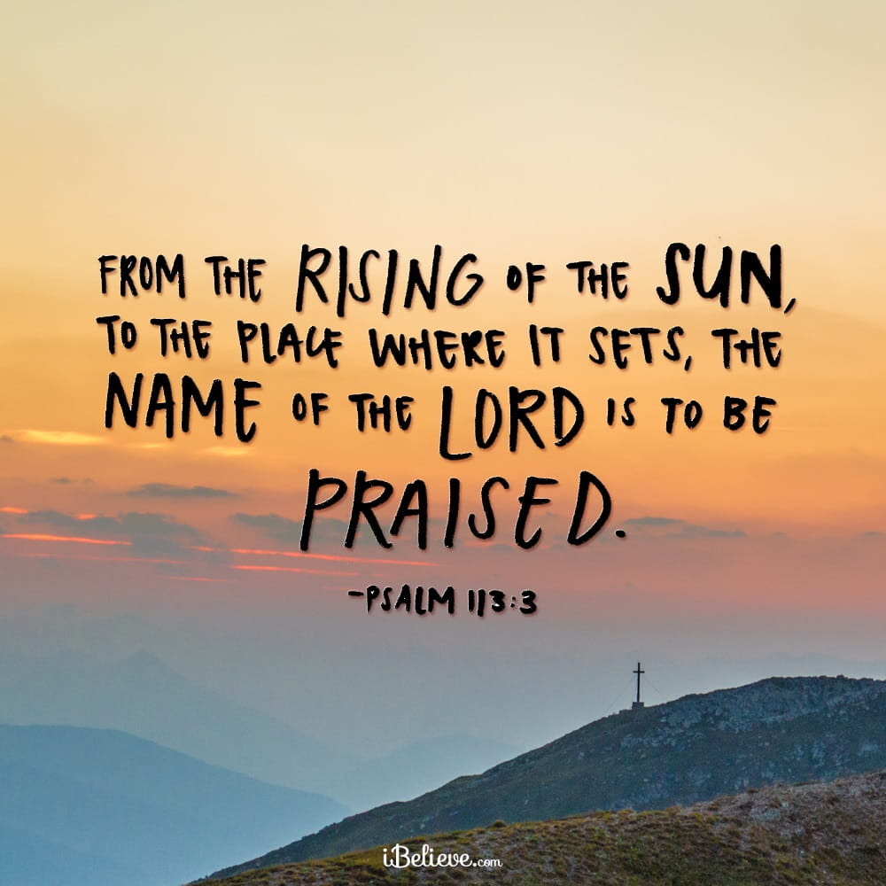
Welcome to all of our visitors, members, friends, family.
It is our sincere prayer that something said or done today will be an inspiration and a blessing to you.
If you are searching for a church home, we encourage you
to seek God in prayer and ask if this is where you should
become a part. After service today, we pray that you will
hang around and allow us to get to know you. We thank
. God for you and hope that you will come back and worship
with us again. “This is the confidence we have in
approaching God: that if we ask anything according
to his will, he hears us”
I John 5:14
OUR RECORDS FOR LAST WEEK:

Sunday Morning Class: 22
Morning Worship: 42
Wednesday Night Class 12
Contribution: $2,580
Bruce Morgan, Monica Clark, Jimmy Jackson, Kristine Hungate & Charles Ray. We also need to pray daily for Vicki Jones & Rick Dunn as they are battling with their cancer treatments.

Please keep Bruce and Monica in your prayers. Bruce is still having pain but he is doing better. Please keep him in our prayers.
Please keep Danny and Sherry in your prayers.

Keep Jimmy Jackson in your prayers.
Please keep Tom and Joanna Sharp in your prayers.
Vicki Jones is having problems with her heart and blood pressure. Please keep her in your prayers.
Please keep Ann and John Wiggins in your prayers.
The Crowder’s are in need of our prayers. Please remember them in your prayers.
Pray for Sheila Doan’s brother-in-law Tom Watson had a full body scan and the doctor called to tell him his body is cancer free. God is an awesome God, thanks for all your prayers.
Kelly Elander’s brother-in-law Rick Dunn had more cancer cells, and had surgery to remove cancer from his hip, pelvic and also femur reconstruction and hip replacement surgery. His bone was softer than expected so it took 15 hours for his surgery. Please remember to pray for Rick and their family.
Donna Marshall has asked for prayers for Gayle Marshall, she is having more cancer concerns and will have more surgery.
Please keep Shelia Talley’s dad, James Bowen in your prayers.
Please pray for Gary Kirby, Mark and Don’s older brother. He is having a problem with choking several times a day and has a doctor’s appointment on the 5th of January.
Warren Lawrence fell Wednesday afternoon, he is OK but very sore. Please pray he feels better soon.
Don Kirby asked for prayers for his dear friends Phillip and Kim Pierce and Phillip’s mother Ann. They are going through some very rough times.
Monty Doan’s brother Buck McDonald passed away last week and his memorial service was Friday in Merit at the Cowboy Church. Please remember the family and keep them in your prayers.

For the Month of January
Opening Prayer Don Kirby
Closing Prayer Kelly Elander
Communion Prayer Seth Stone
Song Leader Greg Blake

Today is our Second Sunday potluck January 14th, we hope everyone will be able to stay and enjoy the good food and wonderful fellowship.
***********************************************

We need volunteers to water the plants during the week and on Sunday. Please see Monica Clark.
January Birthdays
07 Greg Blake
08 Phyllis Stromquist
21 Tony Alan Pribble

Pray for the Joshua project.

