

Game Night
Friday March 1st 5:30 or 6:00, Fellowship Hall, bring snack and any games you like to play, Wahoo boards and anything fun!!
February 25, 2024
Union Valley Church of Christ
9424 FM 35
Royse City, TX 75189
Minister: Bruce Morgan
214-417-1405
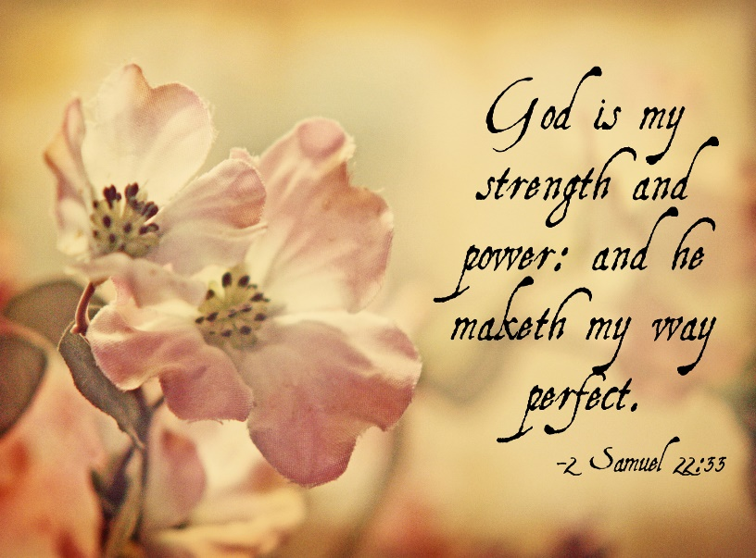

Welcome to all of our visitors, members, friends, family.
It is our sincere prayer that something said or done today will be an inspiration and a blessing to you.
If you are searching for a church home, we encourage you
to seek God in prayer and ask if this is where you should
become a part. After service today, we pray that you will
hang around and allow us to get to know you. We thank
. God for you and hope that you will come back and worship
with us again. “This is the confidence we have in
approaching God: that if we ask anything according
to his will, he hears us”
I John 5:14
OUR RECORDS FOR LAST WEEK:

Sunday Morning Class: 19
Morning Worship: 35
Wednesday Night Class 14
Contribution: $1,380
Bruce Morgan, Monica Clark, Jimmy Jackson, Kristine Hungate & Charles Ray. We also need to pray daily for Vicki Jones & Rick Dunn as they are battling with their cancer treatments.

Please keep Bruce and Monica in your prayers. They are both still having problems, Bruce with his chemo and Monica with her legs. Please keep them in our prayers.
Please keep Tom and Joanna Sharp in your prayers.
Vicki Jones will go back to have her other kidney cleaned in a few months. Please keep her in your prayers.
Please keep Ann and John Wiggins in your prayers.
The Crowder’s are in need of our prayers. Please remember them in your prayers.
Please keep Kelly Elander’s brother-in-law Rick in your prayers as he battles cancer.
Donna Marshall has asked for prayers for Gayle Marshall, she is having more cancer concerns and will have more surgery.
Please keep Shelia Talley’s dad, James Bowen in your prayers.
Donna Marshall is out of the hospital but still not well. Please keep her in your prayers.
Don Kirby asked for prayers for his dear friends Phillip and Kim Pierce and Phillip’s mother Ann. They are going through some very rough times.
Warren Lawrence’s hip surgery went very well. He is doing very well in his rehab. Please keep Warren and Carol in your prayers.
Phyllis Stromquist is in the ICU in Rockwall with double pneumonia. Please keep her in your prayers.
Please keep the Stones in your prayers, Tzeitel has been very sick and in need of our prayers.
Please pray for Gary Kirby, Mark and Don’s older brother. He is better but still in need of our prayers.
Please remember Kelly Elander in your prayers, he is having problems with his mouth.
Please pray for the Jackson’s as Jimmy has the flu.

For the Month of January
Opening Prayer Don Kirby
Closing Prayer Kelly Elander
Communion Prayer Seth Stone
Song Leader Greg Blake

If you would like to be in the rotation for prayers or song leading please contact Danny Myre.

Our next Second Sunday potluck will be March 10th, we hope everyone will be able to stay and enjoy the good food and wonderful fellowship.
***********************************************

We need volunteers to water the plants during the week and on Sunday. Please see Monica Clark.
February Birthdays
06 Monica Clark
08 Julie Elander
12 Ann Wiggins
20 Aven Yarbrough
28 Angel Claudio

