I’m not Crazy after All!
We have this anchor for the soul, firm and secure.
Hebrews 6:19
Am I going crazy? Am I the only person to feel this way? As we go through life, it seems like we occasionally lose our minds.
The challenge of balancing schedules, dealing with demanding personalities, and maintaining relationships and friendships can drive our entire life off course. Like a ship tossed in a storm, we can drift in a strange sea, overcome by uncontrollable waves.
But we do have an anchor, our hope in God. What does an anchor do? It prevents drifting by attaching firmly to the unmoving floor of the sea. God is that seabed, firm and secure, and Jesus is the anchor connecting us to the Father. Our anchor of hope is deep within the seabed of God.
The shape of an anchor reminds us of the cross. No wonder the first-century Christians used an anchor as a symbol of the cross. We are not adrift. We are securely fastened to God through Jesus.
No, you are not crazy when you feel lost and confused. We will have stormy times, but we are held firm and secure by the anchor of hope.

(Although I may feel lost at times, I know You are here with me, holding me secure, giving me hope and strength!)

April 07, 2024
Union Valley Church of Christ
9424 FM 35
Royse City, TX 75189
Minister: Bruce Morgan
214-417-1405
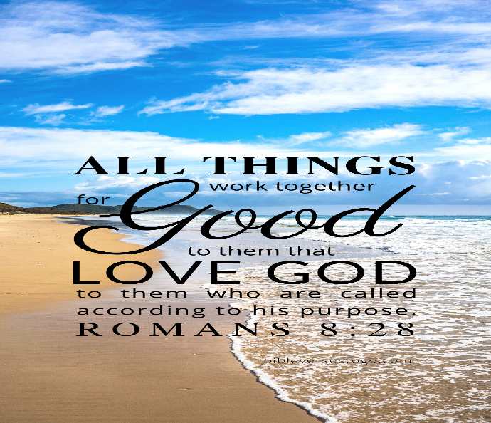

Welcome to all of our visitors, members, friends, family.
It is our sincere prayer that something said or done today will be an inspiration and a blessing to you.
If you are searching for a church home, we encourage you
to seek God in prayer and ask if this is where you should
become a part. After service today, we pray that you will
hang around and allow us to get to know you. We thank
. God for you and hope that you will come back and worship
with us again. “This is the confidence we have in
approaching God: that if we ask anything according
to his will, he hears us”

I John 5:14

OUR RECORDS FOR LAST WEEK:
Sunday Morning Class: 29
Morning Worship: 51
Wednesday Night Class 15
Contribution: $2,208
Bruce Morgan, Monice Clark. Jimmy Jackson, Kristine Hungate & Charles Ray. We also need to pray daily for Vicki Jones & Rick Dunn as they are battling with their cancer treatments.

Please keep Bruce and Monica in your prayers. They are both having problems, Bruce with his chemo and Monica with her legs. Please keep them in our prayers.
Please keep Tom and Joanna Sharp in your prayers.
Please keep Vicki Jones in your prayers.
Please keep Ann and John Wiggins in your prayers.
Please keep Kelly Elander’s brother-in-law Rick in your prayers as he battles cancer.
Donna Marshall has asked for prayers for Gayle Marshall, she is having more cancer concerns and will have more surgery.
Please keep Shelia Talley’s dad, James Bowen in your prayers, he is still having problems.
Warren Lawrence’s hip surgery is doing very well. They are home now and he will do rehab at home. Please keep Warren and Carol in your prayers.
Phyllis Stromquist is in therapy but still very weak. Please keep her in your prayers.
Please keep Patricia and Jimmy in your prayers.

For the Month of March
Opening Prayer Don Kirby
Closing Prayer Kelly Elander
Communion Prayer
Song Leader
If you would like to be in the rotation for prayers or song leading please contact Danny Myre.
Our next Second Sunday potluck will be April 14th, we hope everyone will be able to stay and enjoy the good food and wonderful fellowship.
***********************************************

We need volunteers to water the plants during the week and on Sunday. Please see Monica Clark.

April Birthdays
20 John Wiggins

