Before U was thought of!
Before U were thought of or time had begun, God even stuck U in the name of His Son. And each time you pray, you will see it’s true, You can’t spell Jesus and not include U.
You’re a pretty big part of His wonderful name, for U, he was born, that’s why He came. And His great love for U is the reason He died. It even takes U to spell crUcified.
Isn’t it thrilling and splendidly grand He rose from the dead, with U in His plan. The stones split away, the gold trUmpet blew, and this word resUrrection is spelled with a U.
When JesUs left earth at His Upward ascension, He felt there was one thing He just had to mention. “Go into the world and tell them it’s true. That I love them all, just like I love U.
So many great people are spelled with a U, don’t they have a right to know JesUs too? It all depends now on what U will do. He’d like them to know, but it all starts with U!

April 14, 2024
Union Valley Church of Christ
9424 FM 35
Royse City, TX 75189
Minister: Bruce Morgan
214-417-1405
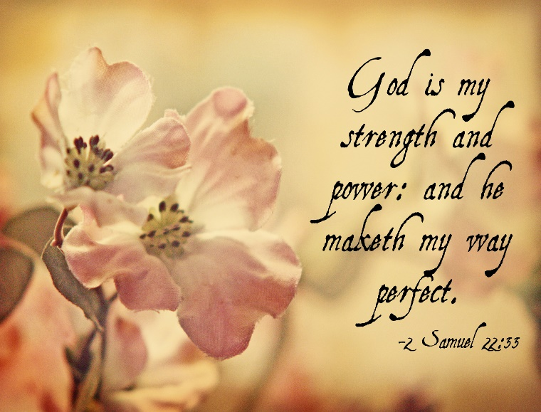

Welcome to all of our visitors, members, friends, family.
It is our sincere prayer that something said or done today will be an inspiration and a blessing to you.
If you are searching for a church home, we encourage you
to seek God in prayer and ask if this is where you should
become a part. After service today, we pray that you will
hang around and allow us to get to know you. We thank
. God for you and hope that you will come back and worship
with us again. “This is the confidence we have in
approaching God: that if we ask anything according
to his will, he hears us”

I John 5:14
OUR RECORDS FOR LAST WEEK:
Sunday Morning Class: 17
Morning Worship: 32
Wednesday Night Class 12
Contribution: $1,700
Bruce Morgan, Monice Clark. Jimmy Jackson, Kristine Hungate & Charles Ray. We also need to pray daily for Vicki Jones & Rick Dunn as they are battling with their cancer treatments.

Please keep Bruce and Monica in your prayers. They are both having problems, Bruce with his chemo and Monica with her legs. Please keep them in our prayers.
Please keep Tom and Joanna Sharp in your prayers.
Vicki Jones had a stroke this past week. After several test they said it was a blood clot that went to her brain. They started her on medicine to dissolve it and will be putting a screen in the artery to stop any other blood clots. It affected her face, speech and left leg but only for a shot while. With the medicine they were able to give her it doesn’t appear she will have lingering problems. Please pray for my daughter.
Please keep Ann and John Wiggins in your prayers.
Please keep Kelly Elander’s brother-in-law Rick in your prayers as he battles cancer.
Donna Marshall has asked for prayers for Gayle Marshall, she is having more cancer concerns and will have more surgery.
Please keep Shelia Talley’s dad, James Bowen in your prayers, he is still having problems.
Warren Lawrence’s hip surgery is doing very well. They are home now and he will do rehab at home. Please keep Warren and Carol in your prayers.
Phyllis Stromquist is in therapy but still very weak. Please keep her in your prayers.
Please keep Patricia and Jimmy in your prayers.

Today is our Second Sunday potluck, we hope everyone will be able to stay and enjoy the good food and wonderful fellowship.
For the Month of March
Opening Prayer Don Kirby
Closing Prayer Kelly Elander
Communion Prayer
Song Leader
If you would like to be in the rotation for prayers or song leading please contact Danny Myre.

***********************************************

We need volunteers to water the plants during the week and on Sunday. Please see Monica Clark.
April Birthdays
20 John Wiggins

Ladies
Now that we have no one cleaning the church building, we need volunteers to clean every other week. Due to the size of our building, we need to break it down by zones.
Zone 1- auditorium, Zone 2 –Foyer, bathrooms, halls, and connecting rooms. Zone 3 – Kitchen, dining area, hall, bathrooms, and connecting rooms where the back door is. Each zone needs to be cleaned twice a month and finished by Sunday. You can sign-up for more than one zone if you wish. There will be a sign-up sheet on the bulletin board.
Then in a few months there will be an “all Ladies deep cleaning”. The cleaning supplies are in the supply room.
Thank you for helping out with this very important task.

